‘Star Trek Medical Dashboard’ style Gauge

The horizontal / vertical gauge symbol is quite basic and there is no option to set visible upper or lower limits, or view data in context of its desirable operating range.

Can you therefore create a ‘Star Trek medical dashboard’ style moving analogue gauge, such as that shown below. This would align with the recommendations within “ANSI/ISA-101.01-2015 Human Machine Interfaces for Process Automation Systems, ISBN 978-1-941546-46-8“, which gives guidelines on the creation and use of high efficiency HMI displays.
The basic gauge shown in figure 32.1 has the significant advantage in that it shows the indicated value in context, i.e., where it sits within its desirable operating range, and its proximity to its Hi and Lo alarms – the alarm region changing colour when the value enters the alarm ranges as shown in figures 81.1 and 91.1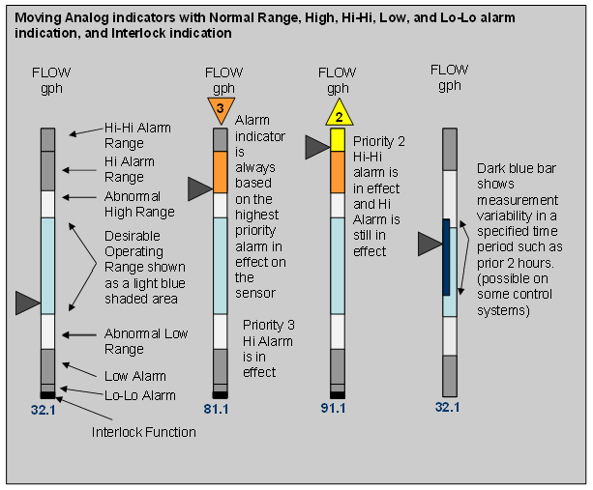
The priority warning triangles are separate to the gauges, as they can be used in numerous other situations as well.

This type of gauge, or bank of gauges, allows the user to see at a glance, the data in context. The image below being taken from the High Performance Handbook:
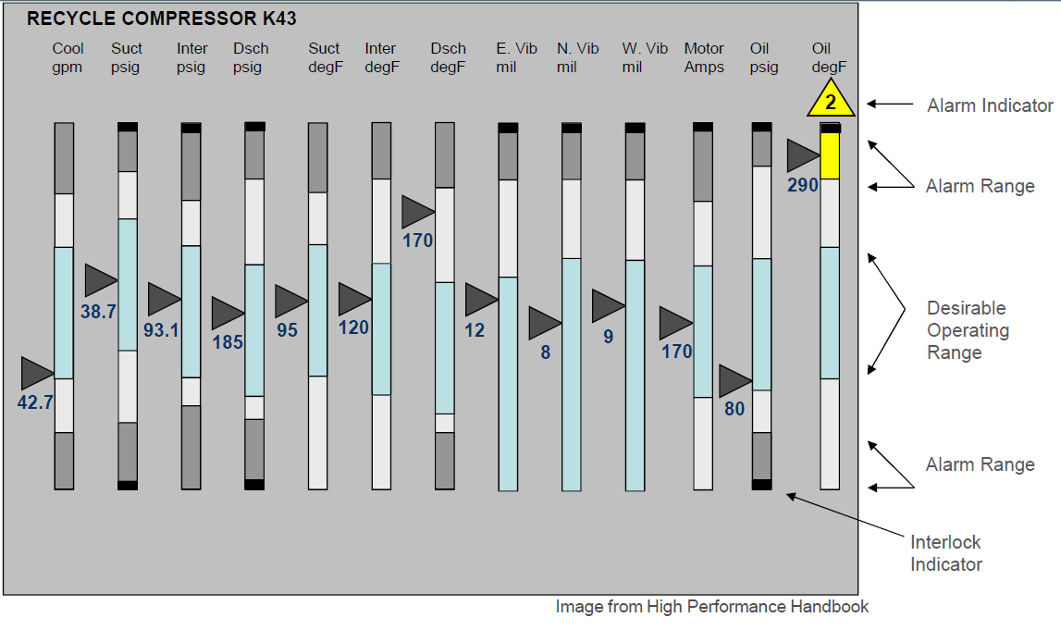
Having solicited feedback from colleagues, engineers and ProcessBook / Vision users, there is a definite interest in this.

